Interview page 3

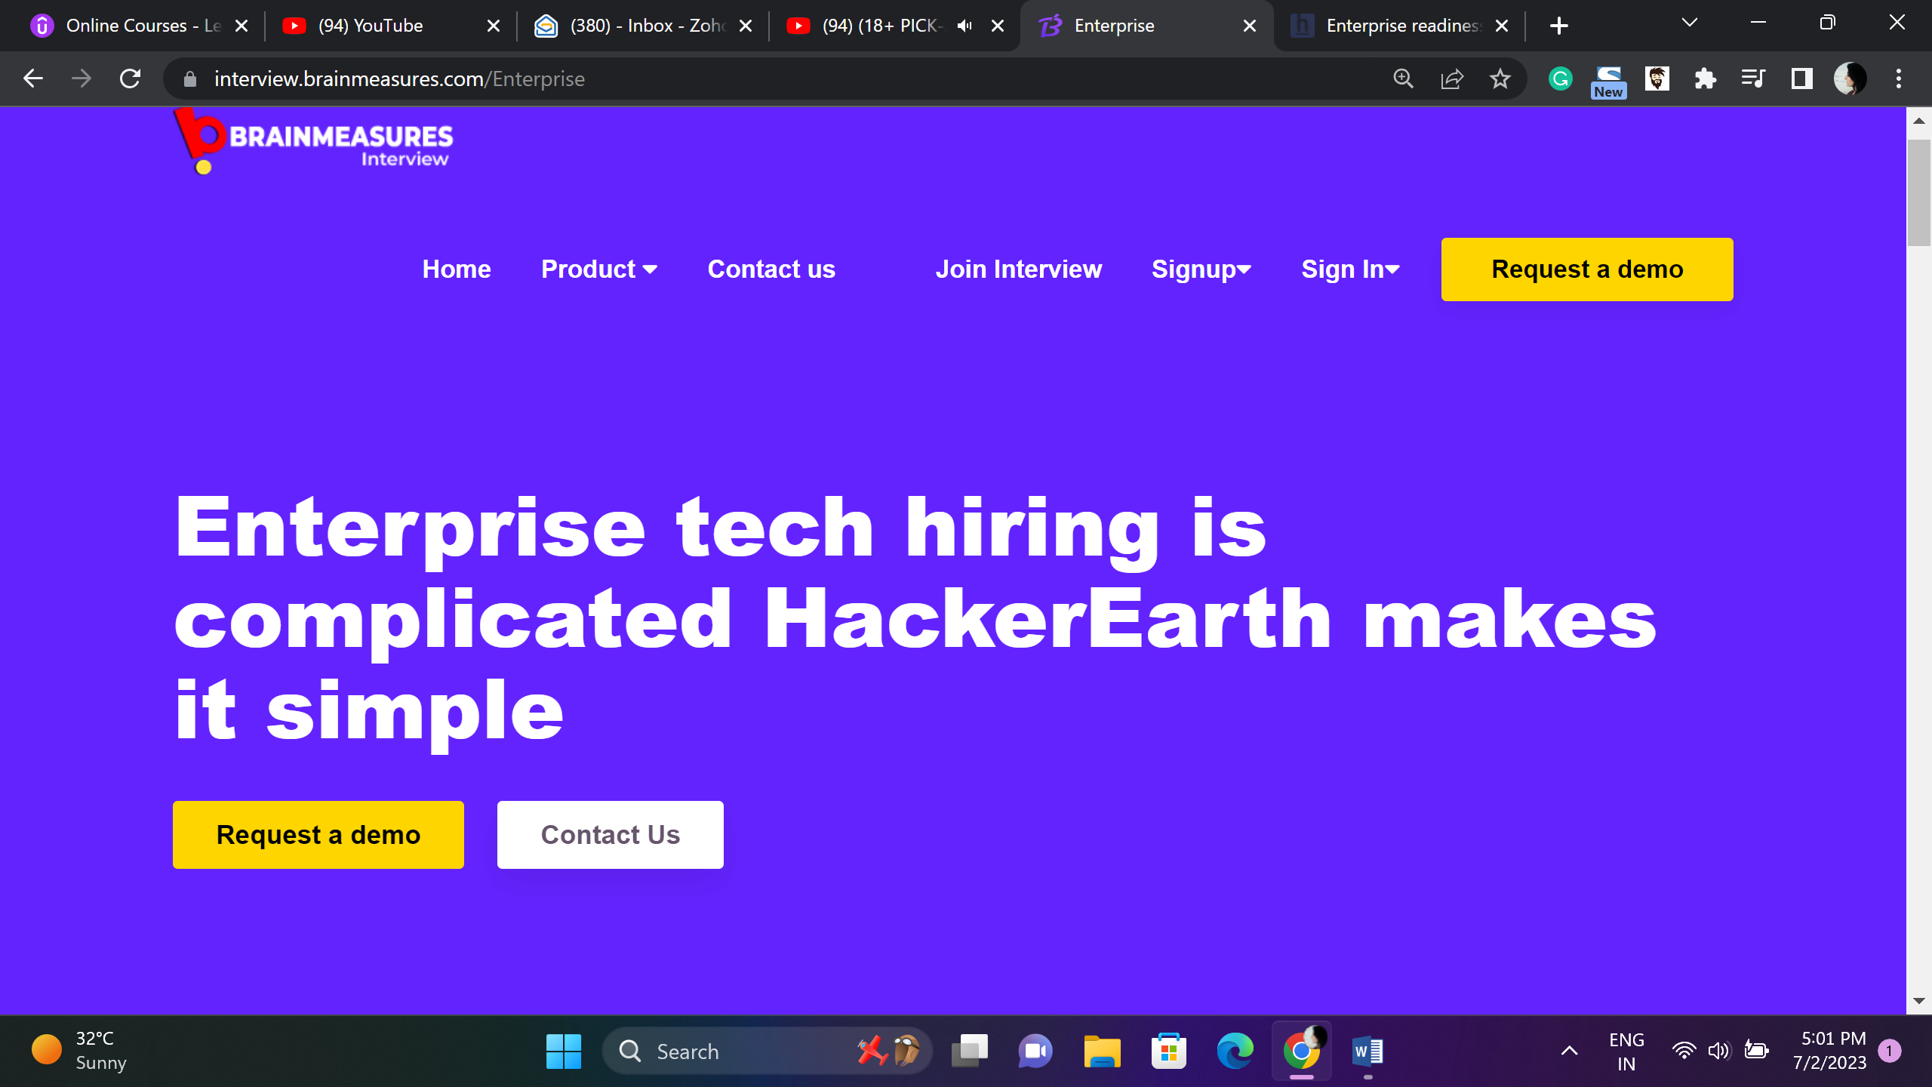

Uncomplicate Tech Hiring – Brainmeasures is one stop solution to all your hiring needs

Request Demo Contact Us

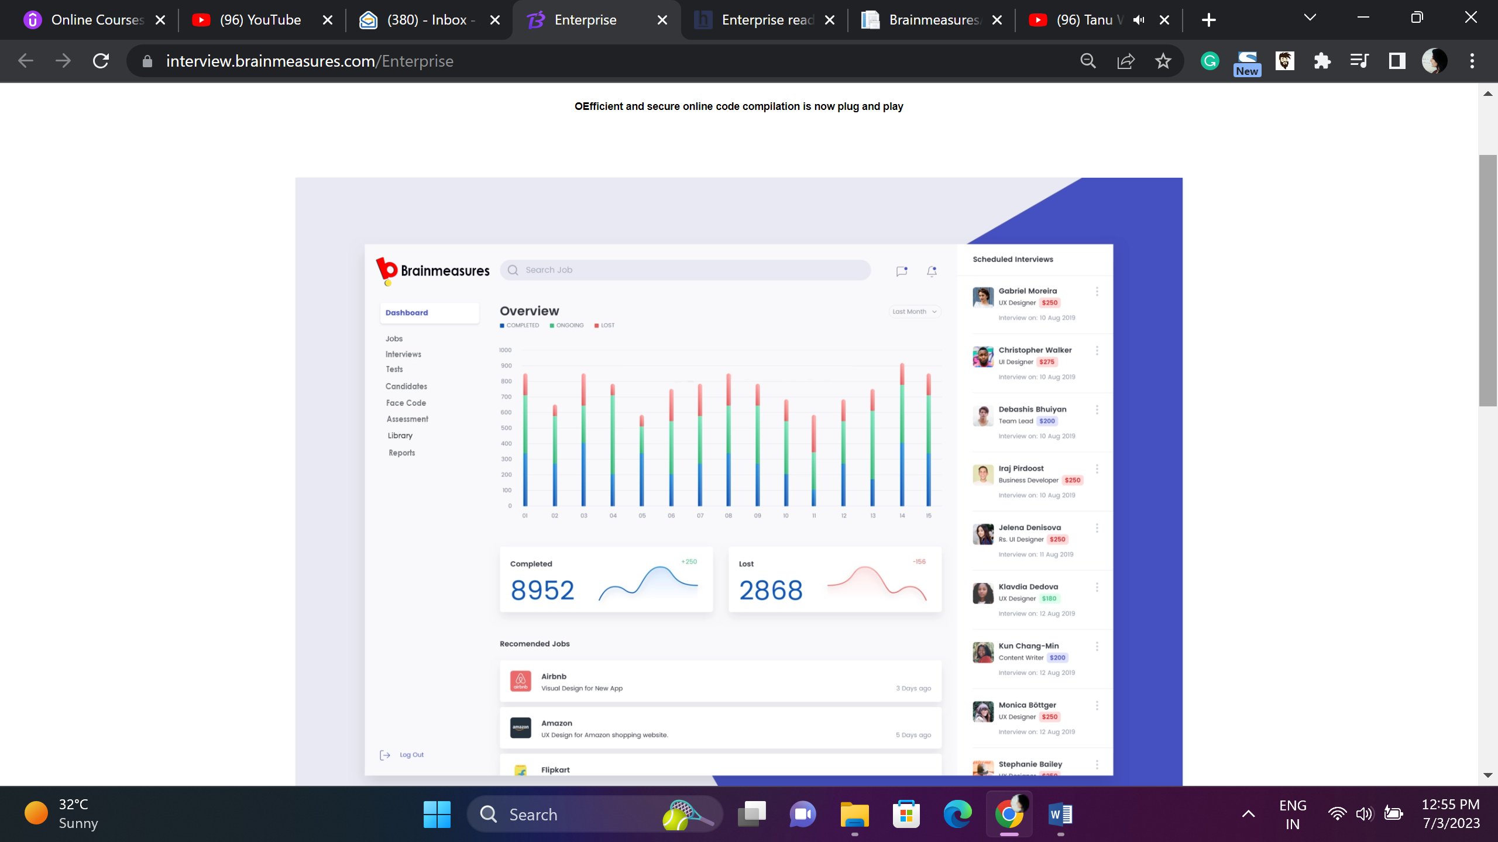

Efficient and Secure Online code compilation is now plug and Play

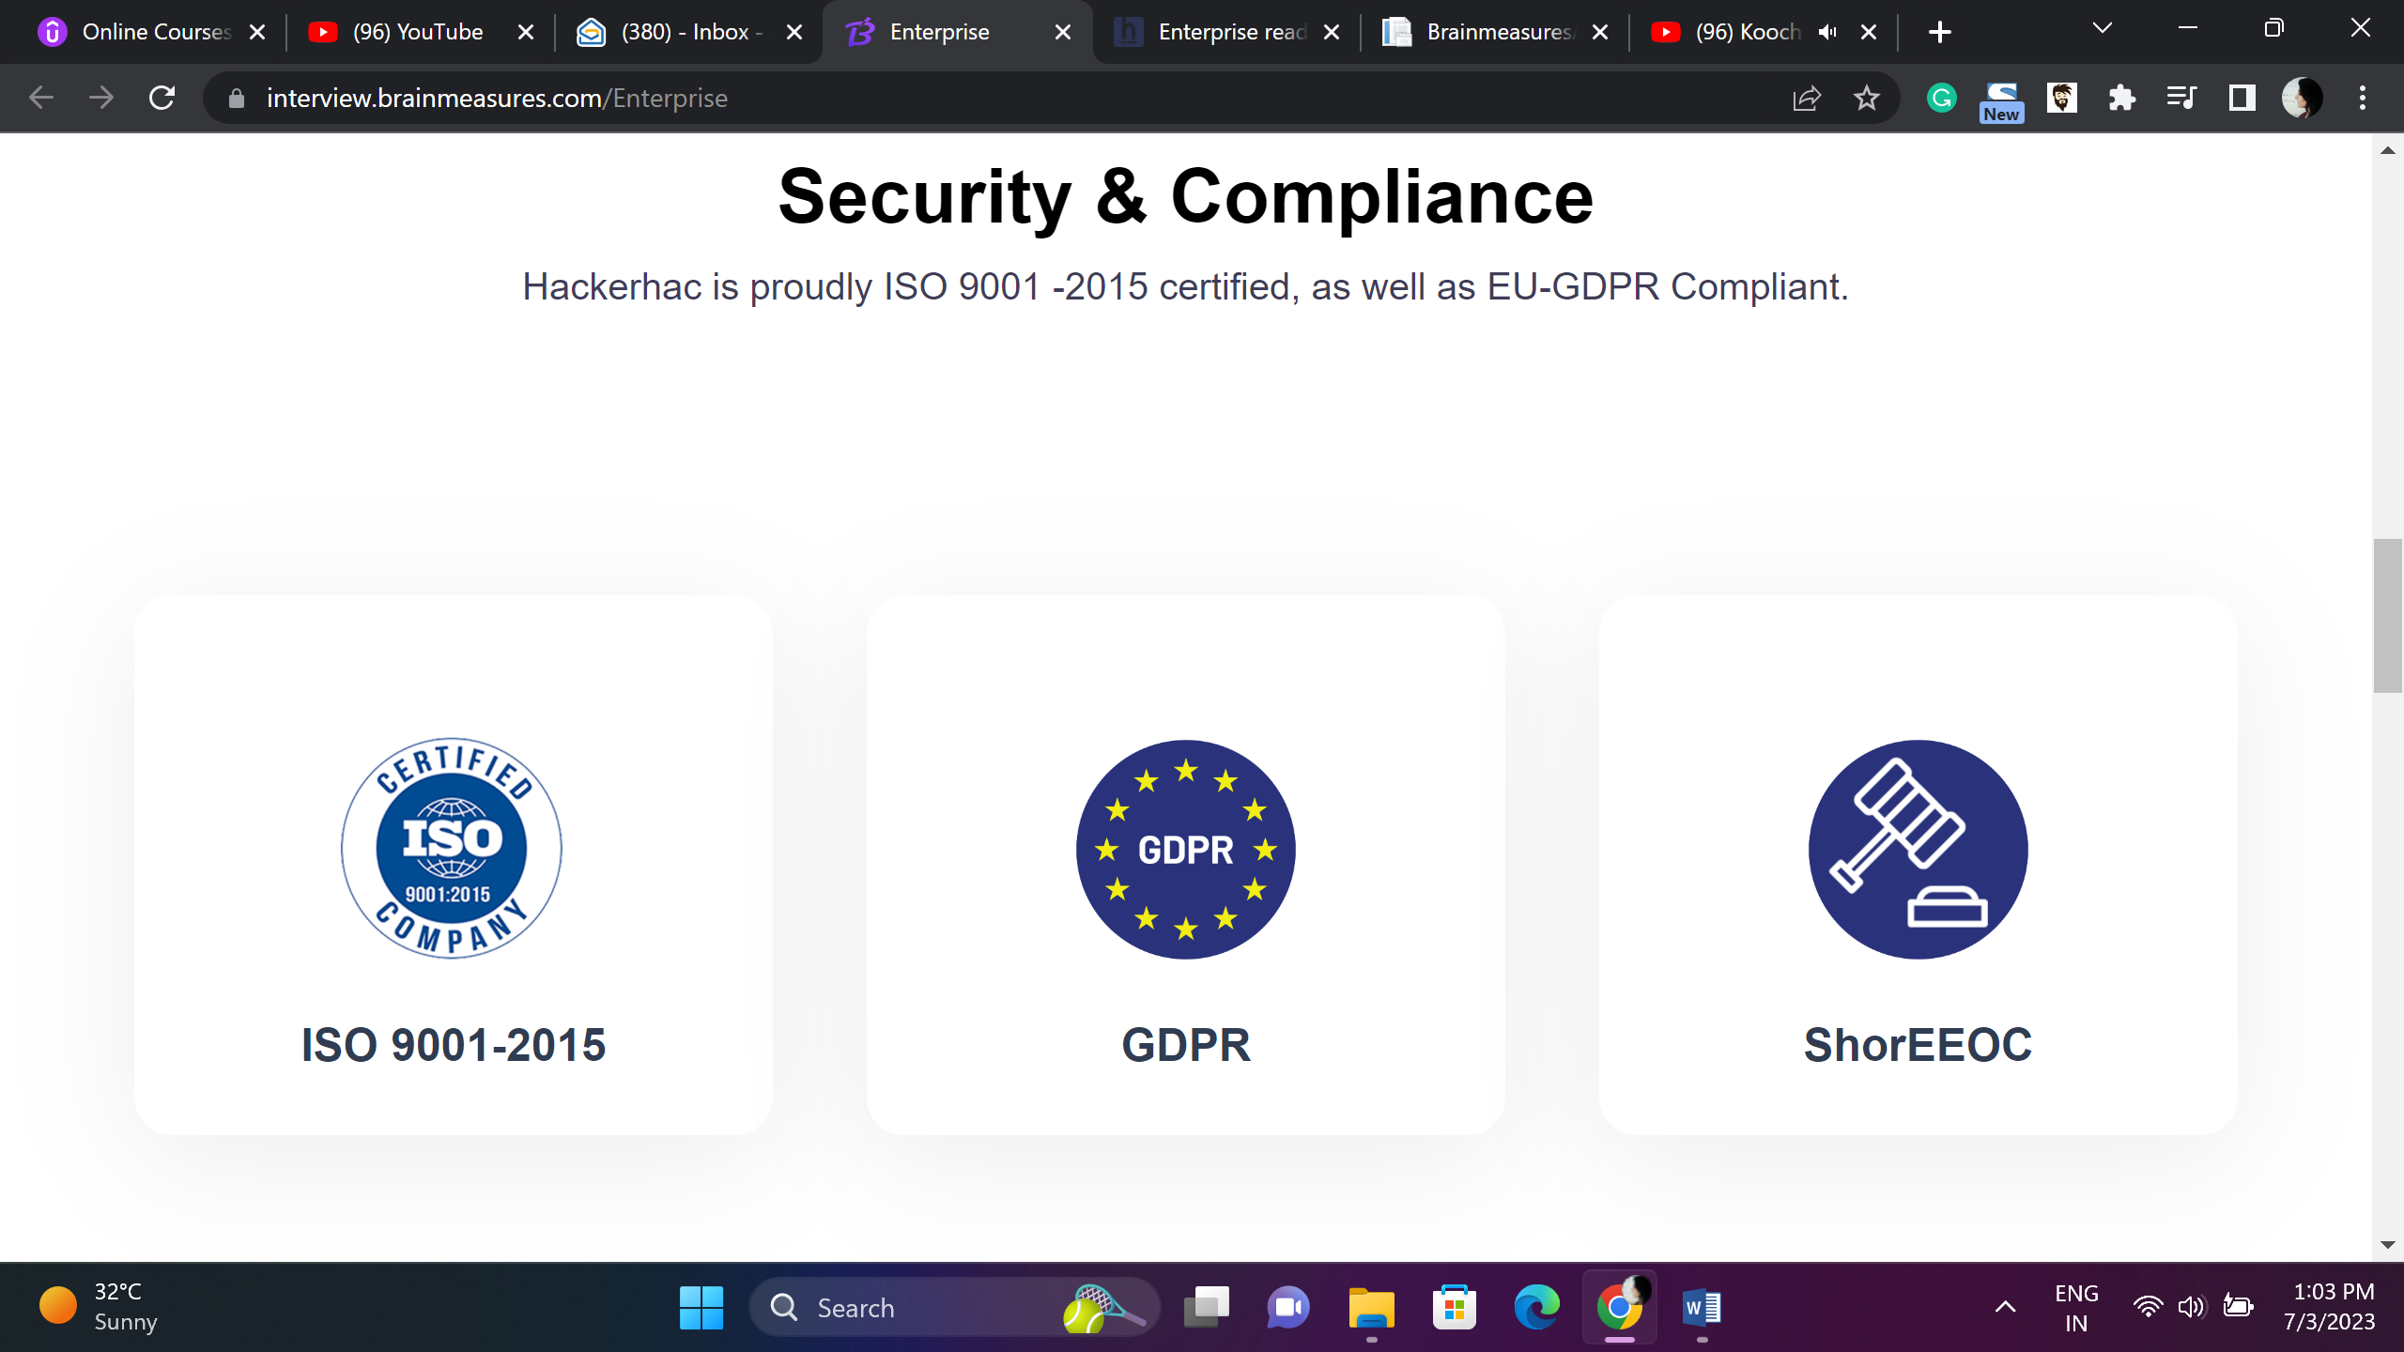

Security & Compliance

Brainmeasures is recognized and certified by Major bodies globally.

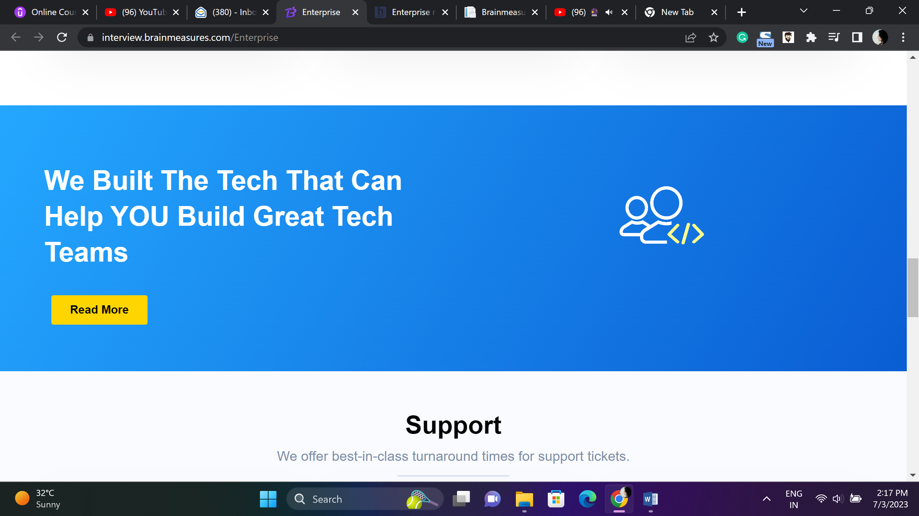

**AI and ML based Tech Hiring Platform – Build Teams That Deliver**

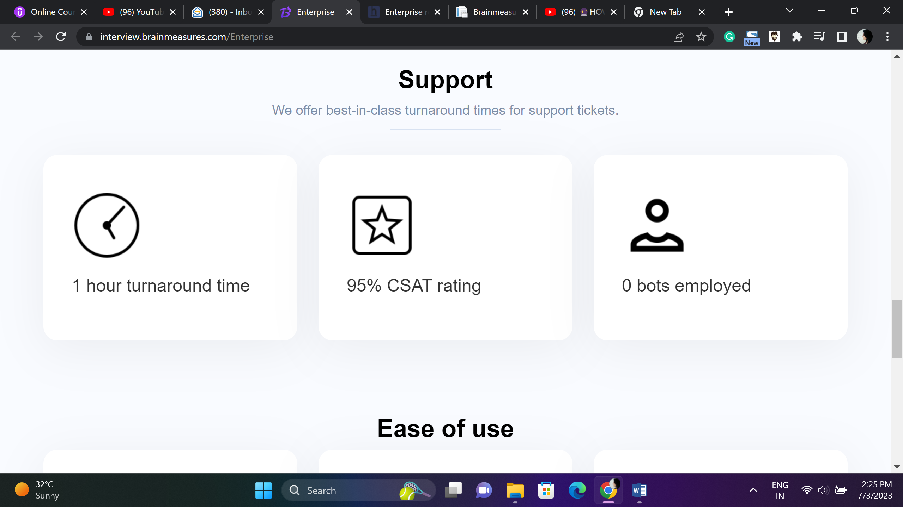

**24X7 Support**

**Our support teams work round the clock.**

**Get your emails answered within an hour**

**95% CSAT Rating**

**Human Support Teams no Bots**

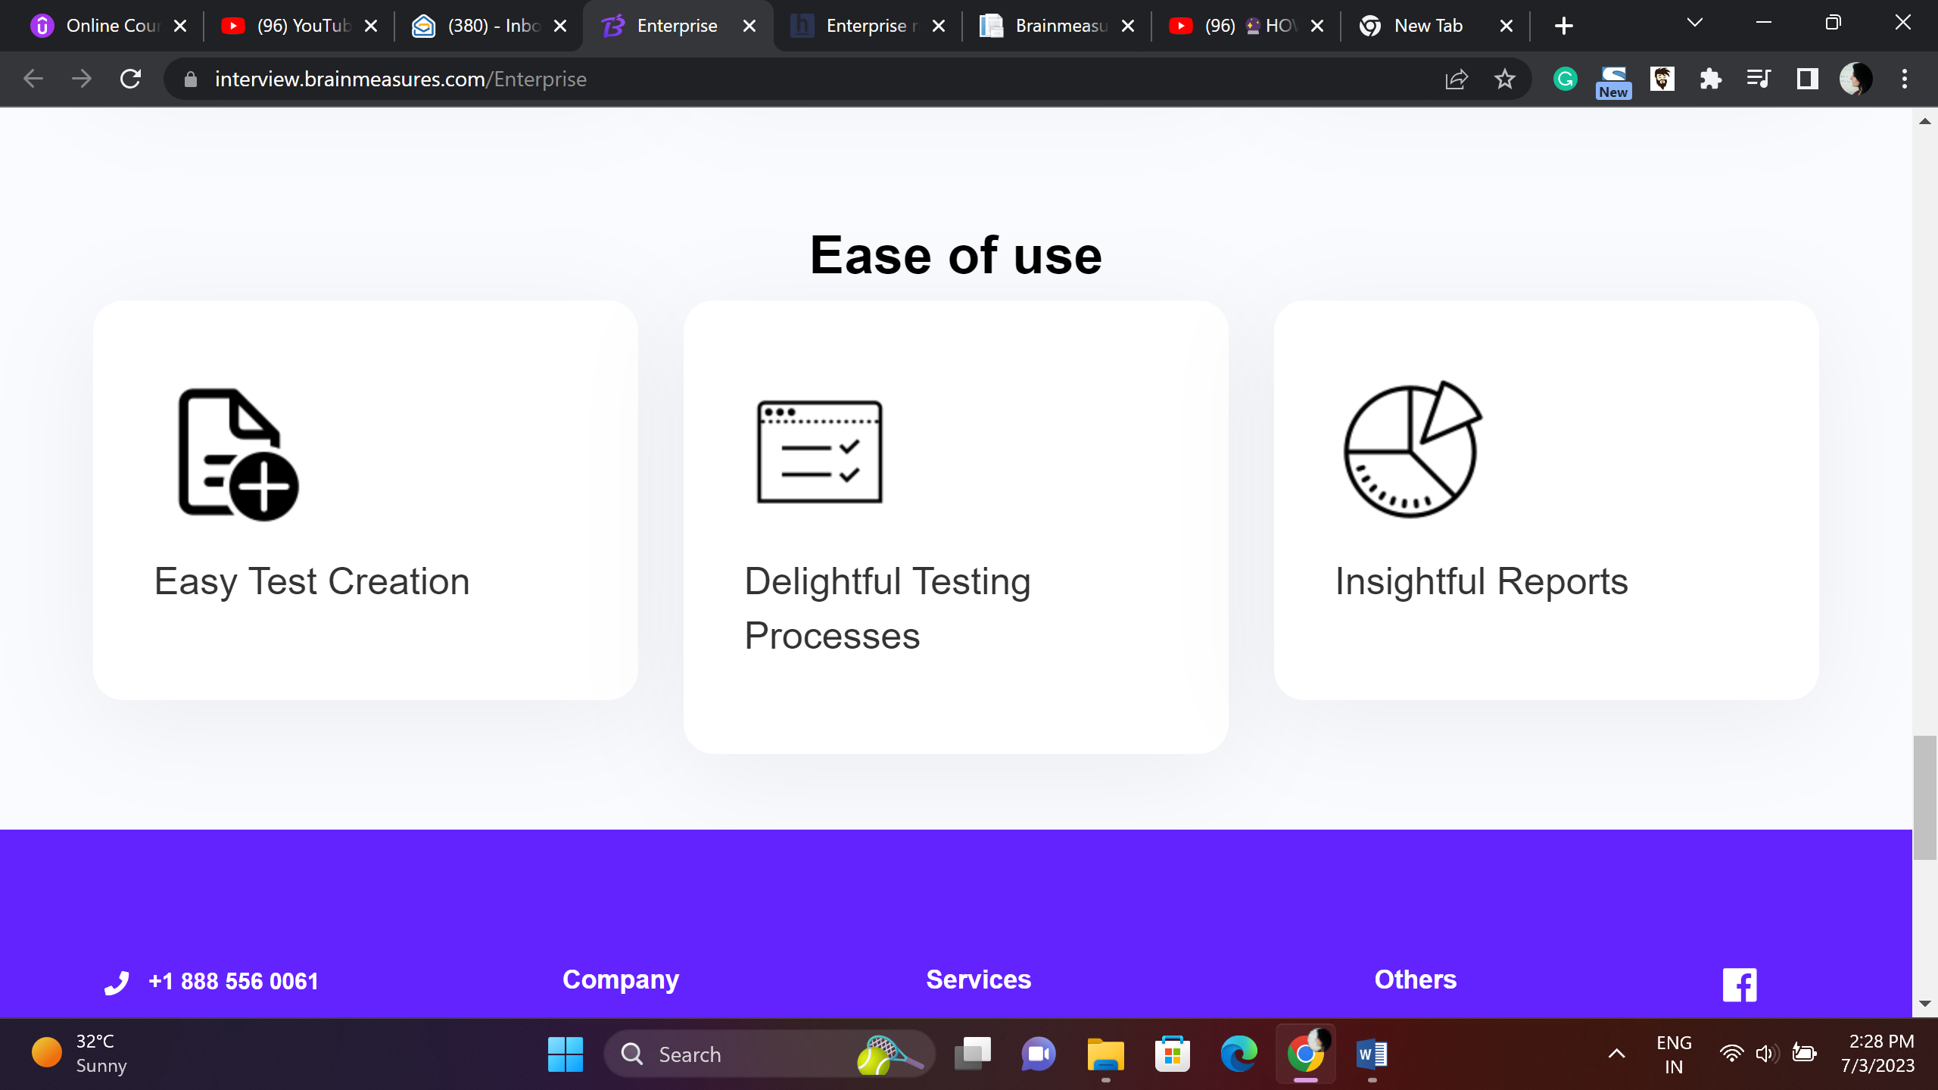

**User Friendly System**

**AI powered dev-friendly platform, create assessments to find right talent**

**Easy Test Creation**

**Congenial Testing Processes**

**Detailed Analytics Reports**

